TCP/IP Project
Design Documentation

Jaymz Boilard
Jared Hudson
Brendan Neva
Steffen L. Norgren

BLAW 3600 • BCIT • March 16, 2009

Application Design & Diagrams 2

GUI Mockup 2

Overview 2

Application 2

Client Main 2

Client Download 2

Server Download 2

Non-multicast Server 2

Multicast Server 2

Microphone 2

Client Upload & Server Download (from Client) 2

Pseudo-code 2

Application 2

Client Main 2

Client Download 2

Server Download 2

Non-multicast Server 2

Multicast Server 2

Microphone 2

Client Upload & Server Download (from Client) 2

Application Design & Diagrams

GUI Mockup

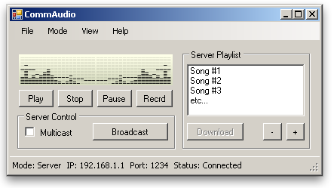
figure 1: Server Mode
We have decided to incorporate the client and server side of this project into a single application. As such, various aspects of the application will be enabled or disabled based on the mode in which the application is currently operating.
The main abilities of the client/server application is the ability to control what is currently streaming through the play/stop/pause functions. Additionally, the record function will cause all currently streaming/multicast sessions to cease and bring the application into recording mode.
All functions are available to the GUI while in server mode except for the download function, as it will always be the client that downloads from the server. Specific functions available to the server are as follows:
  - Multicast – Set the server into multicast mode, allowing new client connections until the server begins to broadcast.
  - Broadcast – Block all future client connections and begin broadcasting the playlist to currently connected clients.
  - Add to Playlist (+) – Opens up the file dialogue box, allowing the user to select files to add to the playlist queue.
  - Remove from Playlist (-) – Removes selected files from the playlist.

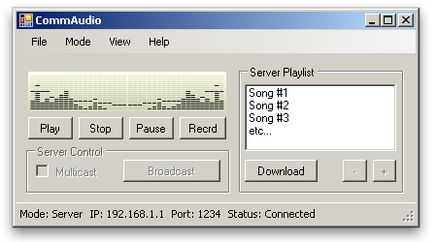
figure 2: Client Mode
While the application is in client mode, all server related functions are disabled, however, the previously disabled “Download” function, is enabled for the client. The download option, however, is only enabled if the client is in streaming mode with the server, not multicast mode. This function allows the client to download any of the selected songs in the playlist.
Additionally, if the client is in streaming mode with the server, the client will have control over which songs in the playlist to play. This is done by selecting the songs in the playlist that the client wants to stream. When the client presses play, it will notify the server which songs to stream to the client.

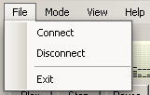
figure 3: File Menu
The file menu allows both the client and server to exit the application. However, the behaviour of the “Connect” and “Disconnect” menu items differ based on the mode for which the application is currently set.
While in server mode, the “Connect” menu item will cause the server to start listening for clients. Meanwhile, the “Disconnect” menu item will cause the server to stop listening for new clients and terminate any open connections.
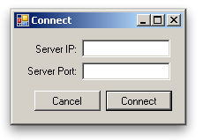
figure 4: Connection Options
If the application is in client mode, the “Connect” menu item will cause a connection options dialog open, prompting the client to enter the server’s IP address as well as the server’s port. By pressing “Connect” the application will first verify the correctness of the IP address and port and then test to see if a server exists at the specified port and IP address. If any of the settings are in error, or the server does not exist, an error message will be presented to the client, allowing the client to re-enter the connection settings and try again.
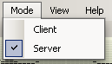
figure 5: Mode Menu
The mode menu allows the user to set whether the application is operating in client or server mode. Changing the application’s mode will enable and disable any functions which are not relevant to that mode’s operation. Additionally, the user will be unable to change the application’s mode while the client or server is connected.

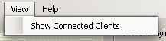
figure 6: View Menu
The view menu allows the user, while in server mode, to view a list of connected clients. This list will appear as a separate window that shows each client’s IP address. This list will be updated dynamically, adding and removing clients from the list as they connect and disconnect.

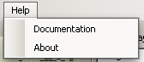
figure 7: Help Menu
The help menu allows the user to view the application’s user documentation as well as an about box, which displays the applications version and the developers involved with the application.
The user documentation window will either be a rich text document that is opened through an external program (WordPad) or a built-in dialogue box.

Overview
This is the main overview of how our design documents are organized.
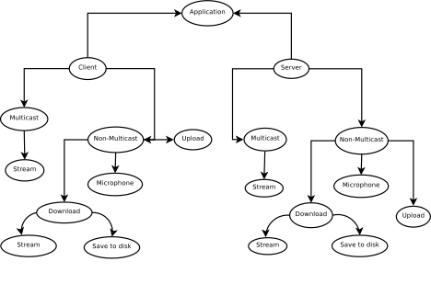figure 8: Application Overview

When the application starts up you have the option of being a client or server.
If you are the client you can either be a multicast or non-multicast client. Multicast clients can only stream the music being played by the server whereas non-multicast clients can upload, have a microphone conversation or download which consists of streaming or saving the file.
If you decide to be the server you can also be multicast or non-multicast. If the server is multicast all it does is play the songs to the IP’s in the multicast IP group. Non-multicast servers can stream a song to a client, have a microphone conversation or download songs from the client. The server-side download portion of the overview symbolizes the server handling how the clients download.
*Note: Wherever a UDP socket is created a long with a new service thread, the thread that initialized them goes to the wndProc listening for messages.
**Note: The rectangles are states and the ellipses are connection points to another diagram.

Application
This is the main entry point for the program. The program waits for the user to enter the settings which calls the corresponding functions. The server is started first and waits for client connections. If it’s the correct type of connection, it will accept, otherwise it will send a busy message.
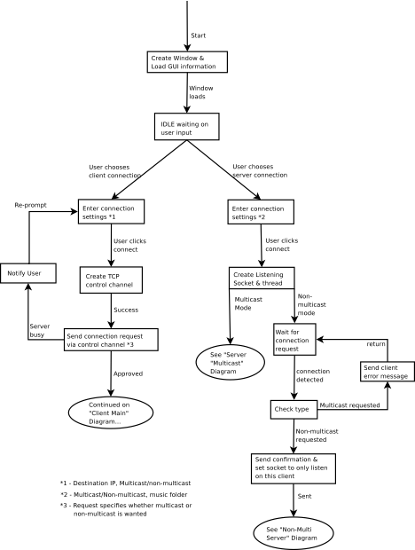
figure 9: Application

Client Main
The following diagram is how the client deals with the server while in non-multicast mode. The client’s input is from what the user selects and is sent to the server via a server control channel.

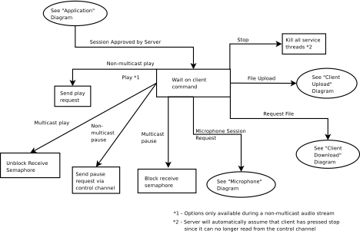
figure 12: Client Main

Client Download
Handles the download for both multicast and non-multicast as well as streaming or save to disk. If it’s streaming we use UDP otherwise we use the control channel. The client chooses to download a song, depending if it’s multicast or non-multicast determines the outcome. The server will send an EOF message when it is done sending the file(s). If there are multiple files, the server will take out the EOF message between songs until the last one.

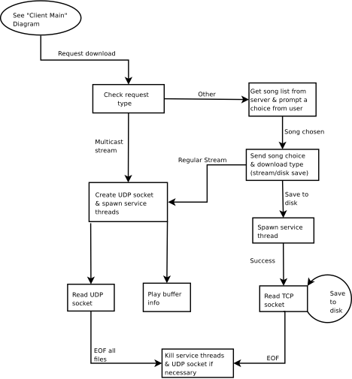
figure 10: Client Download

Server Download
This diagram shows how the server handles a download request from the client. By the time we get here, the server has already accepted the client connection so there is no need to send a confirmation to the client, acknowledging the request. Instead we just send the song list and wait for the user’s song choice and whether they choose to stream or save the file. If stream was chosen then the server will use UDP whereas if save is chosen then it will use the control channel.

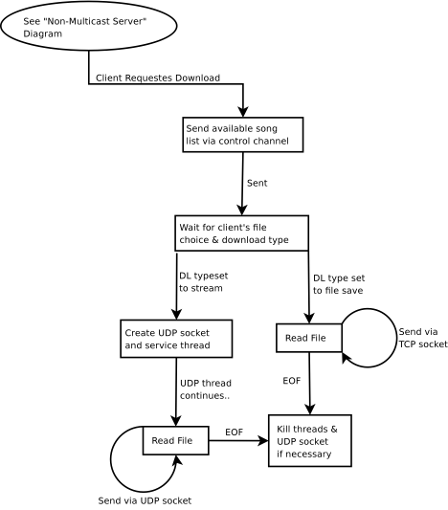
figure 11: Server Download

Non-multicast Server
This diagram shows how the server responds to client input via the control channel while the server is in streaming mode (non-multicast mode).
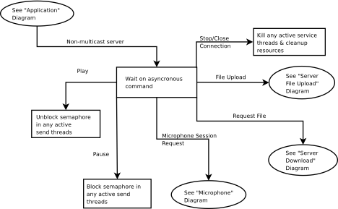

figure 13: Non-multicast Server

Multicast Server
The server continues to wait for incoming connections in which the client includes its own IP address and connection settings. If the client connection is multicast then the server will add its IP to the multicast group. It will continue to wait for connections until a client clicks the broadcast button which will start the stream. If a client connects while this is happening, it will send a busy message.

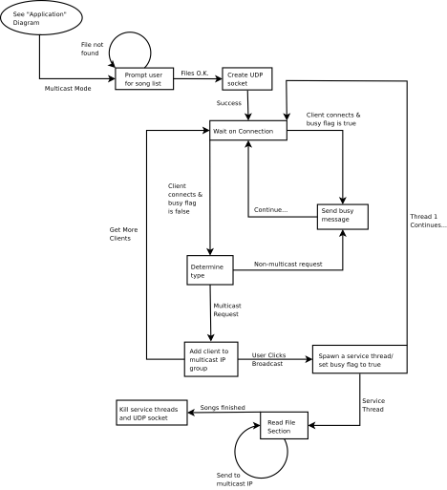

figure 14: Multicast Server

Microphone
This diagram shows how the client/server works when there is a microphone connection. Since it’s a two way connection in which both can send and receive, it will be the same on the client and server.
Note: since the main thread is still getting user input, the send thread will act similar to a multicast server in that when we press pause it will block the receive semaphore on the client. This way the client can prevent feedback caused by sending the data that he/she is receiving through the speakers (noise).

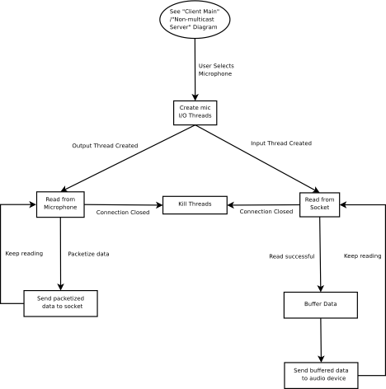
figure 15: Microphone

Client Upload & Server Download (from Client)
The diagram on the left is how the client handles an upload and the one on the right is how the server handles the client upload.
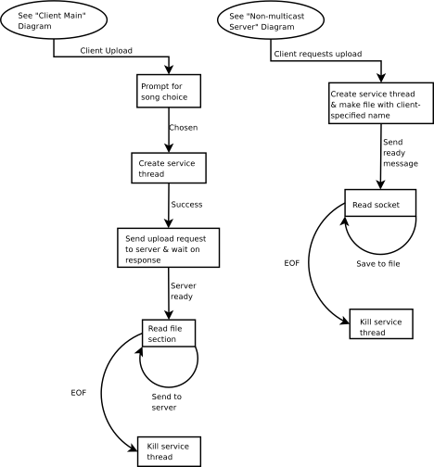

figure 16: Client Upload & Server Download (from Client)

Pseudo-code

Application
Main start
set and register the window properties
create the window
enter wndProc message loop
Main end

wndProc start
allowable messages:
WM_CREATE:
initialize any data structures necessary
for tracking state information
enable/disable GUI items as necessary
WM_SIZE
move main window
move all child windows
WM_PAINT
redraw the window items & text fields
WM_COMMAND
call handle_inputs function
wndProc end
handle_inputs start
input messages:
connection choice:
if server, set type to server
if client, set type to client
connect button:
get connection settings from the text fields
if settings are set to multicast server:
call serverMulticast function
if settings are set to non-multicast server:
listen for client connection request
on connection, check the request type:
if muticast requested:
send error message & continue listening
if non-multicast requested:
send confirmation & set socket
to listen to only this client
call nm_server function
if settings are set to client:
create a TCP control channel
send a connection request to the server
via the control channel
if server is busy or connection type doe
not match:
notify the user and re-prompt
connection settings
if server approves the session:
call client_main function
handle_inputs end

Client Main
client_main start
user inputs/requests:
Non-Multicast Play (only available during a stream)
send play request to server via control channel
Non-multicast Pause
send pause request to server via control channel
Multicast Play
unlbock receive semaphore
Multicast Pause
block receive semaphore
File Upload
call client_upload function
Microphone Session
send microphone request to server via control channel
if accepted
call microphone function
Request File
call client_download function
Stop
kill all service threads & UDP socket (if exists)
client_main end

Client Download
client_download start
if request is multicast:
call udp_services function
if request is non-multicast:
get song list from the server
prompt the user to choose a song from the list
send the server our song choice & download type (TCP/UDP)
if we want to stream (UDP):
call udp_services function
if we want to save to disk (TCP):
create a service thread
service thread:
read the TCP socket, storing it to a buffer
save buffer data to file
if EOF is found:
kill service thread
client_download end
udp_services start
create UDP socket
create service threads
thread 1:
play information stored in buffer
thread 2:
read UDP socket & store in buffer
if we have read to EOF on all files
kill service threads
kill UDP socket
udp_services end

Server Download
server_download start
Send song list via control channel
wait for response
if response is ‘stream’
create stream thread
if response is ‘download’
create save thread
server_download end

Stream thread start
create & bind UDP socket
loop reading contents from file
store in buffer
send buffer to UDP socket
if EOF
close socket
Stream thread end

Save thread start
create & bind TCP socket
loop reading contents from file
store in buffer
send buffer to TCP socket
if EOF
close socket
Save thread end

Non-multicast Server
nm_server start
client requests:
Play
unblock send semaphore
Pause
block send semaphore
Stop/Close connectoin
kill all send threads
cleanup resources (such as sockets)
Request File
call server_download function
File Upload
call server_upload function
Microphone
call microphone function
nm_server end

Multicast Server
serverMulticast start
prompt user for song list
if the file isn't found:
re-prompt
create UDP socket
wait for a client to connect until the user clicks broadcast
client connects and busy flag is set to true:
send a busy message to that client
client connects and busy flag is set to false:
if client's request is for a non-multicast session
send a busy message to that client
if client's request is for a multicast session
add the client's IP to the multicast IP group
continue getting more clients

set the busy flag to true
spawn a service thread
loop copying sections of file to the buffer
send buffer information to the multicast IP group
when all songs are finished:
kill service thread
close UDP socket & resources
serverMulticast end

Microphone
microphone start
Create input thread
Create output thread
microphone end

input thread start
Open socket
if open successful
read while connection active
add data to buffer
play buffer
input thread end

output thread start
Open socket
If open successful
Read while play button active
Packetize buffer
Send packetized buffer to socket
output thread end

Client Upload & Server Download (from Client)
server_upload start
create file with specified name
create service thread
send ready message
while not EOF
read socket data and save to the file
kill service thread
server_upload end

client_upload start
create service thread
prompt for file choice
create service thread
send upload request //wait for response

while not EOF
read file & send data over control channel //TCP
kill service thread
client_upload end

